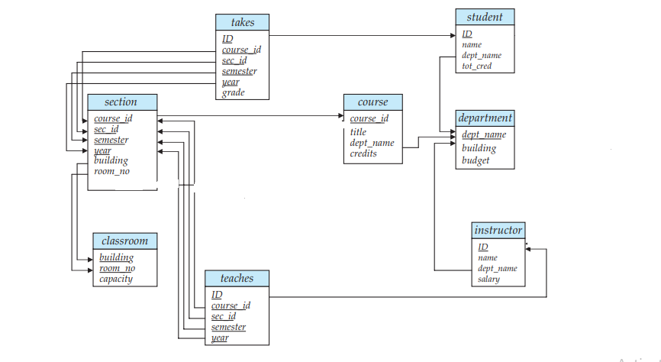

Instructor table:

|  |  |  |  |
| --- | --- | --- | --- |
| ***ID*** | ***name*** | ***Dept_name*** | ***salary*** |
| 22222 | Einstein | Physics | 95000 |
| 33333 | Korth | Computer Science | 75000 |
| 45454 | Mozart | Music | 60000 |
| 55555 | Navathe | Computer Science | 100000 |

Department table:

|  |  |  |
| --- | --- | --- |
| ***dept_name*** | ***building*** | ***budget*** |
| Physics | AB-I | 100000 |
| Computer Science | AB-II | 150000 |
| Maths | AB-III | 80000 |

Section table:

|  |  |  |  |  |  |
| --- | --- | --- | --- | --- | --- |
| ***course_id*** | ***sec_id*** | ***semester*** | ***year*** | ***building*** | ***room_number*** |
| CS-2201 | CS-21 | 1 | E2 | AB-II | 112 |
| Ph-101 | PUC-11 | 1 | P1 | AB-I | 111 |
| MA-201 | CS-21 | 1 | E2 | AB-II | 112 |
| CS-3201 | CS-31 | 1 | E3 | AB-II | 101 |

Teaches table:

|  |  |  |  |  |
| --- | --- | --- | --- | --- |
| ***ID*** | ***course_id*** | ***sec_id*** | ***semester*** | ***year*** |
| 22222 | CS-2201 | CS-21 | 1 | E2 |
| 22222 | CS-3201 | CS-31 | 1 | E3 |
| 45454 | MA-201 | CS-21 | 1 | E2 |
|  |  |  |  |  |

Student table:

|  |  |  |  |
| --- | --- | --- | --- |
| ***ID*** | ***name*** | ***dept_name*** | ***tot_cred*** |
| 1000 | Kshitiz | Computer Science | 80 |
| 1001 | Mike | Computer Science | 70 |
| 2000 | Virtuos | Maths | 60 |

Takes table:

|  |  |  |  |  |  |
| --- | --- | --- | --- | --- | --- |
| ***ID*** | ***course_id*** | ***sec_id*** | ***semester*** | ***Year*** | ***grade*** |
| 1000 | CS2201 | CS-21 | 1 | E2 | A |
| 1001 | CS3201 | CS-31 | 1 | E3 | A |
| 1000 | MA-201 | CS-21 | 1 | E2 | B |
| 1001 | CS2201 | CS-21 | 1 | E2 | A |

Course table:

|  |  |  |  |
| --- | --- | --- | --- |
| ***course_id*** | ***title*** | ***dept_name*** | ***credits*** |
| CS-2201 | DBMS | Computer Science | 4 |
| CS-3201 | OS | Computer Science | 4 |
| MA-201 | PS | Maths | 3 |
| Ph-101 | Physics-1 | Physics | 3 |

Classroom table:

|  |  |  |
| --- | --- | --- |
| ***building*** | ***room_no*** | ***capacity*** |
| AB-II | 112 | 100 |
| AB-I | 111 | 80 |
| AB-II | 101 | 70 |

1. Find the names of the instructors(other than computer science) whose salary is greater than at least one instructor in the computer science department
2. Increase the salary of instructors by 3% whose salary is less than average salary of their departments.
3. Display the course titles and instructor names taken by the student named ‘kshitiz’
4. Display the course titles and department name conducted in building ‘AB-II’ class room ‘112’
5. Display the student name who have taken all the courses in Computer Science department
6. Display the highest credit subjects in each year-semester
7. Display ids and titles of courses which are offered in computer science department in either semester1 or semester 2 of ‘E2’
8. Find the number of students who have taken course sections taught by instructor ‘Korth’
9. Display the details of the students who got ‘A’ grade in all the courses he has taken